ALL TEST 6.31 Analysis Results

Performance Summary

Bottom Line
This induction motor is operating normally, no action is required.
X This induction motor exhibits suspicious operation, trending of the induction motor is warranted.
This induction motor exhibits abnormal indications, action is warranted, NOW.

Power Factor Commentary
Power factor exceeds 0.85.
X Power factor is below 0.85, see detailed report.

Current Commentary
X Current variation is within normal limits.
Current variation is beyond normal limits, see detailed report.

Voltage Commentary
X Voltage variation is within normal limits.
Voltage variation is beyond normal limits, see detailed report.
RMS voltage differs from nameplate by more than 5%.

Load Commentary
X Load on the induction motor is consistent with nameplate values.
Load on the induction motor exceeds nameplate values, see detailed report.
Load on the induction motor is less than 25%.

Phase Connection Commentary
X Connections are normal.
Voltage ground reference is NOT neutral.
Loose connection.

Rotor Commentary
Rotor bar health is normal.
X Rotor bar health is questionable, see detailed report.
Load is insufficient to determine rotor bar health, at this time.

Stator Commentary
X Stator health is normal.
Stator mechanical health is questionable. .
Turn to turn short.

Rotor/Stator Air-gap Characteristics
X Dynamic or static eccentricity indications do not exist.
Indications of static eccentricity exist .
Indications of dynamic eccentricity exist.

Harmonic Distortion Commentary
X There is no evidence of harmonic distortion.
There is evidence of harmonic distortion, see detailed report.

Misalignment Indications
X There are no indications of mechanical problems like misalignment or unbalance.
There are indications of mechanical problems like misalignment / unbalance. Perform vibr. survey to identify and correct the cause.

INPUT SUMMARY

NAMEPLATE INFORMATION
 |  | Units
Serial Number | JB/18680-2008
Model Number | Y2-250-6
Tested Equipment | Induction
Power | 49.60 | HP
RPM | 980.0 | Rpm
Poles | 6
Phases: | 3
Voltage | 380.0 | Volt
Full Load Current | 70.70 | Amp
No Load Current | 3.00 | Amp
Number of rotor bars | 58
Number of stator slots | -1
Torque | 265.7 | Ft.Lb
CT Ratio | 1.000
Service Factor | 115
Motor efficiency | -1.000
Power factor | 0.860

Description:
Belum ada data rotor bar dan stator slot

LEGENDS:
Impedance | = Complex Impedance = vi/ci
CF | = Crest Factor = (waveform peak)/(waveform rms)
VDF | = Transformer Harmonic De-rating Factor = sqrt(2)/CF, %

Slip % | = SRSS sum of slip and harmonic "levels" divided by RMS level of RMS DEMOD spectra between 0 and 65 Hz.
Upper sb | = dB level of upper slip sideband of power line peak
Lower sb | = dB level of lower slip sideband of power line peak
Se, fund | = Location of pole pass frequency fundamental, Hz
Se, harm | = Number of pole pass frequency harmonics
Rotor bar health | = Estimate of the percent of broken or cracked rotor bars
RB Hlt Index | = Rotor bar health index

THDF | = Voltage De-rating Factor = 100 - (voltage unbalance, %)^2, %
Level | = Sum of spectral amplitudes of pole pass frequency fundamentals and harmonics
Thd | = Total harmonic distortion
+Ve | = Positive sequence harmonic
-Ve | = Negative sequence harmonic
Zero | = Zero sequence harmonic

Detailed Calculations

Running Speed = 13.947 Hz [837 RPM]

Pole pass frequency = 16.571 Hz [994 RPM]

Load = 69.5 %
Time
 | RMS | Peak | CF
Current 1 | 52.370 | 75.961 | 1.450
Current 2 | 52.700 | 74.807 | 1.419
Current 3 | 52.380 | 74.357 | 1.420
Average | 52.483 | 75.042 | 1.430
% dev | 0.4 | 1.2 | 1.4

THDF = 98.9

Time
 | RMS | Peak | CF
Voltage 1 | 392.300 | 555.130 | 1.415
Voltage 2 | 392.500 | 555.180 | 1.414
Voltage 3 | 392.300 | 547.240 | 1.395
Average | 392.370 | 552.520 | 1.408
% dev | 0.0 | 1.0 | 0.9

VDF = 100.0

 |  |  | App. Power | Real Power | Reac. Power
 | Power factor | Impedance | kVA | kW | kVARS
Phase 1 | 0.788 | 7.491 | 11.862 | 9.348 | 7.302
Phase 2 | 0.789 | 7.448 | 11.937 | 9.414 | 7.339
Phase 3 | 0.786 | 7.489 | 11.864 | 9.323 | 7.337
Avg/Total | 0.788 | 7.476 | 35.662 | 28.085 | 21.978
% dev | 0.2 | 0.4

Demand Pwr = 37.65 HP

Load:69.5 %

Motor Eff.:91.7 %

Loss due to THD:

Output Pow.:25.41 KW

Output Trq.:213.70 Ft.Lb

Summary of Rotor Bar Health |  |  |  |  | Power line dB diff. |  | RB Hlt Index
 | Se, fund |  | Se, harm | Level % | Upper SB | Lower SB | RB Hlt Index
Measured | 16.571 |  | 1 | - | -52.604 | -50.857 | 0.338
Severity level |  | Rotor Condition Assessment |  |  | Recommended Corrective Action
3 |  | Slight indication of rotor problems |  |  | Continue surveys, trend only

Harmonic Distortion Results:
Voltage input, from 50.049 Hz harmonics
 | THD Odd % | THD Even % | +ve% | -ve % | Zero % | THD All %
Current 1 | 0.699 | 0.145 | 0.361 | 0.606 | 0.105 | 0.713
Current 2 | *** | *** | *** | *** | *** | 0.000
Current 3 | *** | *** | *** | *** | *** | 0.000
Voltage 1 | 0.767 | 0.027 | 0.198 | 0.738 | 0.072 | 0.768
Voltage 2 | *** | *** | *** | *** | *** | 0.000
Voltage 3 | *** | *** | *** | *** | *** | 0.000

Harmonic distortion table – Peak values, voltage is phase to ground
Hz | Cur1 | Vlt1 | Cur2 | Vlt2 | Cur3 | Vlt3
50 | 75.2 | 317 | *** | *** | *** | ***
100 | 0.1 | 0 | *** | *** | *** | ***
150 | 0.1 | 0 | *** | *** | *** | ***
200 | 0.1 | 0 | *** | *** | *** | ***
250 | 0.5 | 2 | *** | *** | *** | ***
300 | 0.0 | 0 | *** | *** | *** | ***
350 | 0.3 | 0 | *** | *** | *** | ***
400 | 0.0 | 0 | *** | *** | *** | ***
450 | 0.0 | 0 | *** | *** | *** | ***
500 | 0.0 | 0 | *** | *** | *** | ***
550 | 0.1 | 0 | *** | *** | *** | ***
600 | 0.0 | 0 | *** | *** | *** | ***

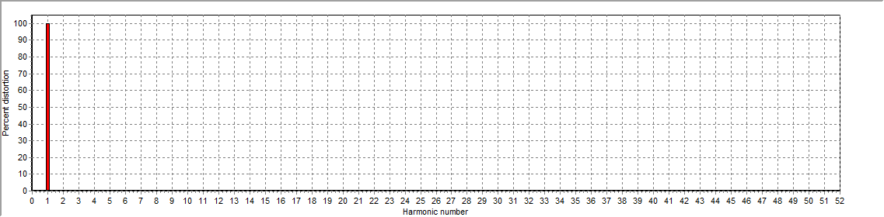
Figure 1: Current harmonic distortion plot

Figure 2: Voltage harmonic distortion plot

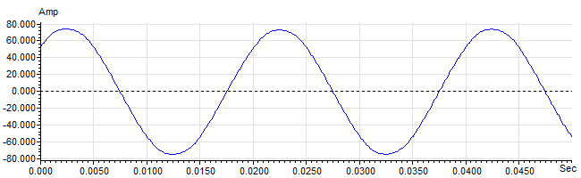
Figure 3: Raw Current

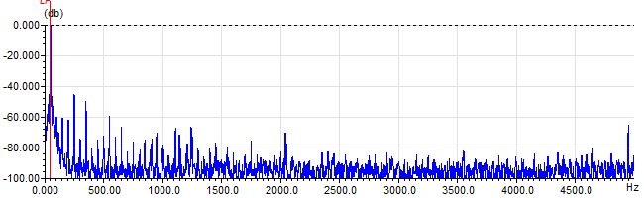
Figure 4: Raw Current Frequency spectrum

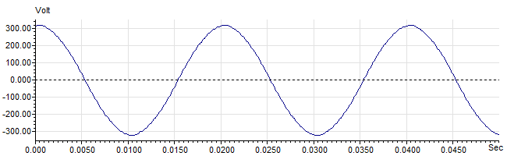
Figure 5: Raw Voltage

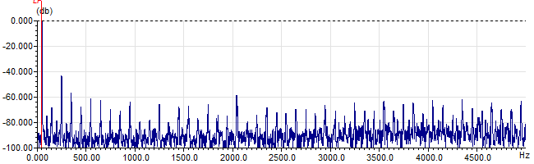
Figure 6: Raw Voltage Frequency spectrum

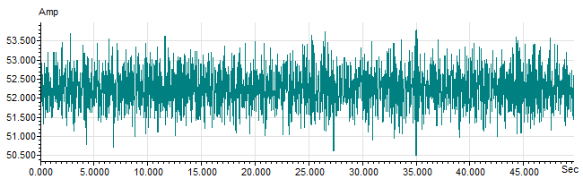
Figure 7: Demodulated current trace

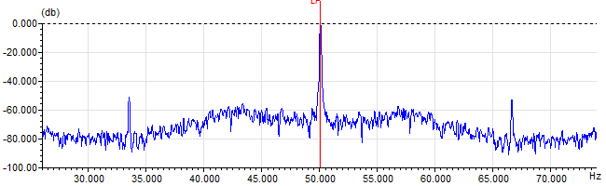
Figure 8: Raw current spectrum

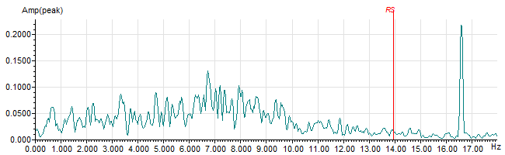
Figure 9: Demodulated current spectrum

